Stevens Institute of Technology

**Research in the 68000 Assembly Language**

Course: CS550 Computer Organization and Programming

Junjie Chen

Professor: Edward Banduk

October 2021

1. **The 68000 Processor**

A microprocessor is a computer processor in which data processing logic and control are contained in a single integrated circuit or in a small number of integrated circuits. Physically, it is a semiconductor integrated circuit chip that integrates a large number of micro transistors and other electronic components.

The Motorola’s 68000 Processor is a 16/32-bit complex instruction set computer (CISC) microprocessor and the most significant of the 32-bit designs of microprocessors, having been released in 1979. It was the most popular CPU design of its class due to its combination of great performance, large memory space (16 megabytes), and relatively inexpensive cost.

Memory is logically addressed in 8-bit bytes, 16-bit words, or 32-bit long words. It requires the alignment of word and long-word data. In bit manipulation instructions, bits are independently addressable.

There are several addressing modes are available:

1. Inherent

Register or memory direct or indirect addressing.

1. Immediate

It can be divided into immediate and quick immediate, which are the next instruction word and the subfield of the instruction, respectively.

1. Relative

The operand address in the instruction is the contents of the specified address register plus a 16-bit signed displacement.

1. Extended

Register direct or indirect addressing with offset.

1. Indexed

The operand address is made up of the contents of the given address register plus the contents of an additional data or address register indicated in the instruction with an 8-bit signed displacement.

1. **The 68000 Assembly Language**

As we all know, computers use binary to work internally. Assembly language is any low-level language used in electronic computers, microprocessors, microcontrollers, or other programmable devices. Assembly languages relate to different sets of machine language instructions in different devices, and each is dedicated to a specific computer system architecture. The 68000 Assembly Language is the specific assembly language used in Motorola 68K-series microprocessors.

Most assembly language uses a mnemonic to represent each low-level machine instruction or opcode, typically also each architectural register, flag, etc. Figure 1 lists instruction mnemonics of the 68000 Assembly Language.

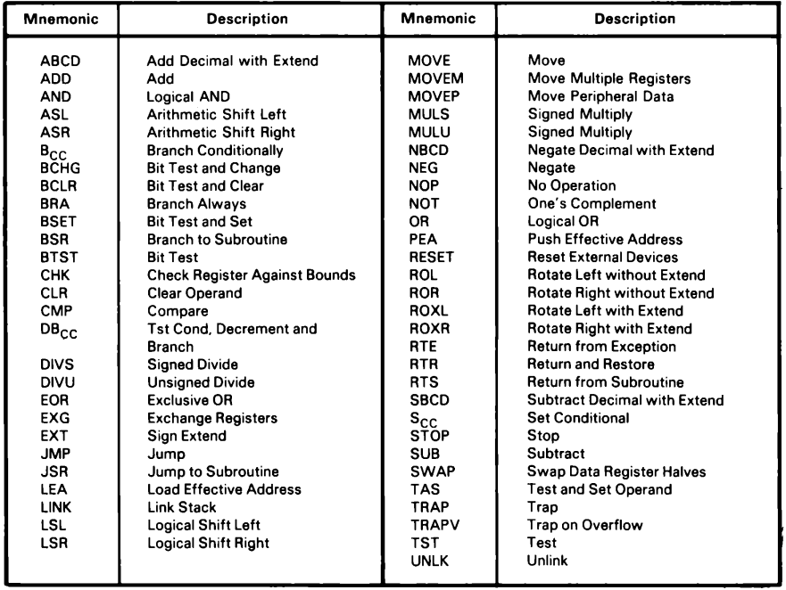

**Figure 1**. Instruction Mnemonics of the 68000 Assembly Language

We can see that most instructions include dot-letter suffixes, allowing for operations on 8-bit bytes (".b"), 16-bit words (".w"), and 32-bit longs (".l") (".l"). And the majority of instructions are dyadic, meaning they have a source and a destination, and the destination can be altered.

1. **Assemblers**

The primary function of assembler is to convert mnemonic operation codes into binary equivalents. The assembler completes this work with the use of a fixed table, much like the table in figure 1.

However, the assembler must do more than simply translate the operation codes. It must also figure out how many and what kind of operands the instruction requires. This can be complicated since certain instructions (such as Stop) have no operands, while others (such as a Jump instruction) have one and others (such as a register transfer or a multiple-bit shift) require two. Some instructions may also provide options; for example, some computers contain instructions (such as Shift or Clear) that can be applied to a CPU register or a memory address.

Some instructions in assembly language are not directly converted into machine language instructions. These are assembler commands that assign the program to specific memory locations, create symbols, designate memory spaces for data storage, place tables or other fixed data in memory, allow references to other programs, and perform minor housekeeping (like memory cleaning) tasks.

**4.** **The 68000 Simulator**

68000 Simulator creates a virtual 68000 microprocessor that runs on your PC. It allows you to run 68000 programs without any 68000 hardware. Among the significant ones are: EASy68K, Crossware 68000 Simulator for Windows.

**References**

[1] Stritter, E., & Gunter, T. (1979). Microsystems a Microprocessor Architecture for a Changing World: The Motorola 68000. Computer, 12(02), 43-52.

[2] Microprocessor - Wikipedia. (2021). Retrieved 3 October 2021, from <https://en.wikipedia.org/wiki/Microprocessor>

[3] 68000 Addressing Modes | Direct Register | Direct Memory Addressing. (2021). Retrieved 3 October 2021, from <https://www.eeeguide.com/68000-addressing-modes/>

[4] Assembly language - Wikipedia. (2021). Retrieved 3 October 2021, from <https://en.wikipedia.org/wiki/Assembly_language>

[5] Kane, G., Hawkins, D., & Leventhal, L. (1981). 68000 assembly language programming. Berkeley: Osborne/McGraw-Hill.

[6] Motorola 68000 - Wikipedia. (2021). Retrieved 3 October 2021, from <https://en.wikipedia.org/wiki/Motorola_68000>